Task No 01: Write a program that takes a positive integer from the console and prints the square root of this integer. If the input is negative or invalid print "Invalid Number" in the console. In all cases print "Goodbye"?

Input:

using System;

using System.IO;

using System.Text;

public class Writer

{

static void Main(string[] args)

{

try { Writing(); }

catch (Exception e) { Console.WriteLine("ERROR"); }

}

static void Writing()

{

Console.WriteLine("Enter the number: ");

double n = Convert.ToDouble(Console.ReadLine());

if (n >= 0)

{

double s;

s = Math.Sqrt(n);

Console.WriteLine("{0} IS THE SQUAREROOT OF THIS NUMBER", s);

Console.WriteLine("GOOD BYE");

return;

}

if (n < 0 || n != 0)

{

Console.WriteLine("Invalid Number");

}

Console.WriteLine("GOOD BYE");

Writing();

}

}

Output:

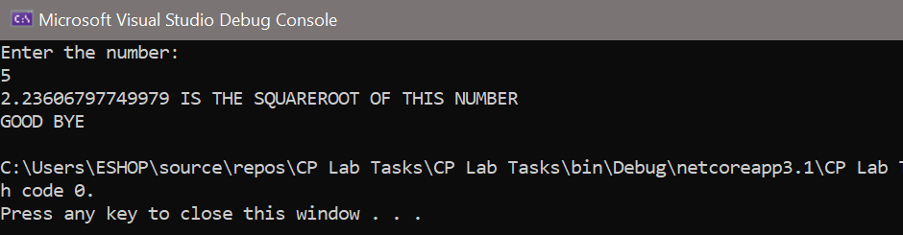

Task No 02: Write a method Read Number (int start, int end) that reads an integer array of 10 values from the console in the range [start…end]. In case the input integer is not valid, or it is not in the required range throw appropriate exception.

Input:

using System;

namespace CP_Lab_Tasks

{

class Program

{

static void Main(string[] args)

{

try { arrayread(1, 5); }

catch (Exception e) { Console.WriteLine("ERROR"); arrayread(1, 3); }

}

static void arrayread(int start, int end)

{

Console.WriteLine("Enter array size");

int size = int.Parse(Console.ReadLine());

int[] array = new int[size];

array[0] = 1;

array[1] = 2;

array[2] = 3;

array[3] = 4;

array[4] = 5;

for (int i = start; i < end; i++)

{

Console.WriteLine(array[i]);

}

}

}

}

Output:

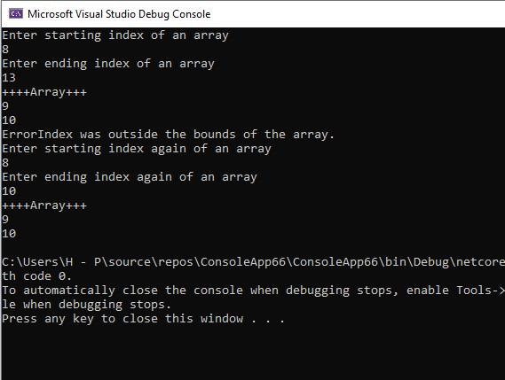

Task No 03: Write a method that takes as a parameter the name of a text file then, reads the file and returns its content as string. What should the method do if an exception is thrown?

Input:

using System;

using System.IO;

using System.Text;

public class Writer

{

static string ans = "y";

public static void Main(String[] args)

{

try { Writing(); }

catch (Exception e) { Console.WriteLine("ERROR"); }

}

static void Writing()

{

if (ans == "y" || ans == "Y")

{

Console.Write("Enter the file name: ");

string Filename = Console.ReadLine();

if (!File.Exists(Filename))

{

Console.WriteLine("{0} does not exist!", Filename);

return;

}

StreamReader sr = File.OpenText(Filename);

string s = "";

while ((s = sr.ReadLine()) != null)

{

Console.WriteLine(s);

}

Console.Write("Do you want to continue [Y/N]: ");

ans = Console.ReadLine();

Writing();

}

}

}

Output:

